**Slum-Driven Design: Inclusion and Incursion Around Essential Entrepreneurship in Brazil’s Urban Favelas**

**Arjun Khara**

School of Design, University of Leeds

Associate Professor of Communication, Information, and Digital Design

ORCID 0000-0002-8146-3781

**Gustavo Orlando Fudaba Curcio**

Faculdade de Arquitetura e Urbanismo e de Design da Universidade de São Paulo

Professor do Departamento de Projeto, vice-presidente do Escritório Internacional

ORCID 0000-0003-0168-0901

**Abstract**

Understanding the complexity and potential of favelas around the world has been a challenge for entrepreneurs. Many have realized the potential for wealth generation in peripheral communities in cities like São Paulo or Mumbai. Startups based on design-based communication strategies quickly flourished. Such strategies are decisive for the success of these innovative business models, which overcome the difficulties and infrastructure impasses of these regions outside the cities. In this article, we present examples developed in Brazil, as part of collaborative research between FAUUSP and the School of Design at the University of Leeds.

**Key-words**

Slum-driven design; Favela; Startups.

**1 Introduction**

If all of Brazil’s slums were organised into a single state, then, according to Instituto DataFavela, that state would have an annual GDP of R$200 billion (approx. US$ 42 billion) behind only São Paulo and Rio de Janeiro. So prominent is the level of entrepreneurship in Brazil’s slums, and the corresponding generation of wealth, that the strength of this informal urban economy has caught the attention of local, regional, and multinational stakeholders, particularly over the last two decades. More recently, from 29 to 31 July 2023, the business fair Expo Favela Innovation took place in Rio de Janeiro; exhibitors were primarily entrepreneurs and startups from the favelas. A primary objective of the fair was to heighten visibility for these initiatives and promote exchanges between Brazil’s slum entrepreneurs and the country’s mainstream or formal investors. At first, such crossovers might appear unfair or even predatory, given the vast differences in the socioeconomic landscapes. However, Renato Meirelles, director of DataFavela, presented the results of an in-depth study on the volume of business generated in these informal communities. Among the massive amounts of wealth generated in the slums, at its core the fair’s aim was to demystify the concept of favelas as sites of economic, social, and even political power. Design thinking plays a significant role in these sites and their activities. Accordingly, this paper seeks to address discourse around slums by reorienting traditional perceptions of marginalised urban dwellings that ultimately produce and consume billions of dollars per year under circumstances that force resourcefulness. As design researchers, we therefore need to highlight and supplement prior sensibilities around the plight of slum dwellers by balancing the realities of paralysing poverty with the potential for enormous profitability, innovation, and disruption. As such, the term ‘slum-driven design,’ is introduced in this paper to describe the degrees of entrepreneurship that arise through compelling, even desperate, circumstances in slums around the world. This paper is the first in our slum-driven design series, and focuses here on Brazil's favelas; future papers will examine slum-driven design in India and Nigeria to draw comparisons and develop an ontology of terms and methods to aid our study.

**2 Slum-Driven Design**

Slums, or squatter settlements, is a term typically referring to subpar housing complexes which are inhabited by communities whose economic means typically fall short of national and international poverty thresholds. As a result, squatter settlements are often located on the margins of urban centres, although some major global metropolises harbour slums in the midst of the city — Makoko in Lagos, Nigeria, and Dharavi in Mumbai, India being prime examples. In both, location plays a role: slums are born, established, and expand due to needs that overwhelm local and regional authorities. Dharavi, for instance, was conceived out of British India’s colonial contentions over migration and manufacturing in Bombay (Mumbai today) towards the end of the nineteenth century. The slum today continues as a micro-economy in Mumbai and is a major centre for textiles, leather works, pottery, and other products. These activities have made Dharavi an intensely popular site for locals and tourists, generating more than US$1 billion annually (NYENRODE BUSINESS UNIVERSITY, 2009). Likewise, necessary or imperative ingenuity in Makoko (sometimes referred to as the ‘Venice of Africa’) has seen its roughly quarter million inhabitants (OTTAVIANI, 2020) employ novel methods of managing their water problems: drinking water is obtained via local micro-sanitisation techniques, or by direct purchase through illegal cartels; and as a waterfront settlement, Makoko addresses flooding by building on wooden stilts (LUMUMBA, 2016). Makoko and Dharavi will be discussed in subsequent papers.

**2.1 Imperative Ingenuity**

Writing about design thinking and innovation, Wylant attributes the significance of “clusters” whereby companies and entities within a geographic region align to co-operate, compete, and ultimately contribute to a specific sector or location (WYLANT, 2008, p. 3). Communal creativity has often been cited for its potential to tap the wisdom of crowds, and slums as geographically-based communities leverage on this feature of design thinking. However, the reasons propelling business successes in slums are unique in that they are not compelled solely by creativity but by crises. Slums have gained significant recognition as sites of resourcefulness, enterprise, and innovation, filled with examples of the urban poor’s capacity to adapt and thrive in extremely challenging conditions (WILLIS, 2009). This capacity arises precisely because squatters are compelled to accept, innovate, or perish in what are arguably some of the most dangerous spots on the planet. Design thinking becomes a matter of survival, which in turn generates new ways and methods of approaching the myriad challenges of dwelling in squatter settlements.

But despite the broad definition encapsulating slums around the world, there are, unsurprisingly, distinct differences and subtle nuances between communities. A challenge particular to Makoko was that large swathes of stilt houses were demolished from 2012 onwards, with little notice to residents, owing to these dwellings not having official or legitimate recognition (OTTAVIANI; ADESHOKAN, 2020) Another difference between communities is that the favelas in Brazil, for instance, enjoy much higher degrees of goods ownership, sewage treatment, and overall standards of living compared to the slums of Mumbai and New Delhi in India (THÉRY; SAGLIO-YATZIMIRSKY; LANDY, 2014). However, Rio De Janeiro’s favelas, home to more than 3.3 million dwellers, are estimated to have no neutral areas that are out of criminal control (BARCELLOS; ZALUAR, 2014) owing to drug gangs, mafias, and militias—many of whom are engaged in continuous conflict to exercise authority over zones and territories. These conflicts are often aimed at acquiring economically viable territories in the favelas, with a goal to dominate control of bottled gas sales, alternative transport, and electronic games (BARCELLOS; ZALUAR, 2014), to name a few of the activities that generate substantial local revenue.

In 2020 alone it was reported that the combined purchasing power of Brazil’s favelas, numbering 13.6 million inhabitants, amounted to US$27.7 billion (MEIRELLES, 2020). Given that businesses in favelas operate largely beyond the scope of government and municipal regulations, the revenue generated is a significant indication of how resourcefulness is born out of, and driven by, extreme necessity. Despite the stark contrast with the flavours of innovation around revenue and profit motives associated with so-called mainstream economic activities on Wall Street, Silicon Valley, London’s Canary Wharf, and Singapore’s, Hong Kong’s, and Sydney’s CBDs, the challenges of daily survival amidst desperation in slum societies give rise to equally impressive results. Given the comparable rates of revenue generation and wealth creation, what drives inequalities—real and perceived—between these two worlds? Ray Bromley’s 1978 study questions the role of the state in perpetuating these dualistic views:

That the formal and informal are seen as separate rather than interdependent; that blanket policy prescriptions are applied to extremely diverse economic activities; that informality is seen as an exclusively urban phenomenon; that the informal economy has a present but no future; that economic activity is confused with places, so that entire neighbourhoods are described as informal; and that informality and poverty are seen as one and the same. (MARX, 2018, p. 8)

Indeed, as Colin Marx states, the recognition of informal societies leads to a number of issues, including loss of land rights through legitimacy issues; positioning informal economies in the “global South as the ‘other’ on which the propulsive, dynamic, productive, advanced economies depend” (MARX, 2018, p.9) leads to a sort of concealed interdependence that recognises the activities of one world often at the expense of the other. The merits and morality around such approaches warrants deep discourse that is beyond the scope of this paper. However, the paper acknowledges the clear distinction in driving forces behind such results, and thus offers the term ‘slum-driven design’ to draw out these differences as well as to categorise and analyse the unique set of circumstances under which imperative ingenuity transpires. Slum-driven design examines the design thinking processes, interactions, and approaches surrounding manufacturing and services, together with the consequences, that are driven by extreme needs across the world’s poorest urban sites.

**3 A Business Case for Slums**

Business ownership in Brazil’s favelas is significantly high: a 2023 study found that “almost 40% of favela residents in Rio de Janeiro have their own business; for 23% this is the main source of income. Among those who do not have their own business, 22% intend to start their own in the next 12 months” (MEIRELLES, 2023). While the nature of these businesses varies, it is their legitimacy—or lack thereof—that is of particular interest. Meirelles’ study points to informality as one of the main challenges for innovation in favelas. Around 57% of businesses in Brazil do not have official registration, i.e. these entities are not filed with the National Register of Legal Entities (CNPJ). The study cites difficulties in obtaining financing to launch a business as one of the most significant challenges, followed by financial management practices, and lack of equipment.

In the early 2000s, C. K. Prahalad (1941–2010) gained worldwide recognition thanks to his study of wealth at the base of the social pyramid. Interestingly, the Indian researcher’s book, T*he Fortune at the Bottom of the Pyramid: Eradicating Poverty through Profits*, includes a Brazilian success case, in which he discusses the strategy of a retailer in the household equipment and furniture sector. In his discussion of India’s poor, he states:

India is home to more than 400 million people who qualify as being very poor. The policies of the government for the first 45 years since independence from Great Britain in 1947 were based on a set of basic assumptions. Independent India started with a deep suspicion of the private sector. The country’s interaction with the East India Company and colonialism played a major part in creating this mindset. (PRAHALAD, 2005).

Pralahad’s observation that the poor feel alienated by the private sector is important when considering how residents of slums see themselves in relation to the booming economies of the cities in which they exist. This is a relevant point to note as this discussion turns to Brazil’s favelas, their economic significance, and the continued struggled experienced by their residents as they attempt to participate in a global economy.

**3.1 The Brazilian Panorama**

Data from 2023 shows that there are 5.8 million households in favelas with 17.9 million residents. Of this total, 5.2 million are already entrepreneurs, 6 million dream of having their own business, and seven in ten intend to open a business within the favela. Despite the impressive numbers, only 37% of businesses are formal.

A study carried out by the Brazilian Business School Insper and the London School of Economics (LSE) revealed that among the 1,700 favelas in São Paulo (12% of the city's population), only 274 house some type of business dedicated to food. On average, for each establishment that primarily sells fresh food (fishmongers, butchers, and fruit and vegetable stores), there are twice as many establishments selling ultra-processed products. Given this reality, outlier cases emerge with counterexamples to this phenomenon. Deficiencies in favela distribution and supply systems, with an emphasis on the food and goods sector, have aroused the interest of entrepreneurs in these regions. A study conducted by the organization Novo Outdoor Social in 2023, called Persona Favela, revealed interesting characteristics of entrepreneurship in favelas:

60% of businesses in favelas are led by women, and 44% of business owners are from generations Y and Z, aged between 18 and 34 years old. The majority (62%) are self-declared black and brown people and work predominantly in the southeast (37%) and northeast (22%) regions. (NOVO OUTDOOR SOCIAL, 2023, n. p.).

The study points out that, although the majority of entrepreneurs act individually, the impact of their businesses goes beyond their own financial independence. “For the majority of respondents, their business impacts at least 10 people, and 35% of business owners have at least 1 employee, including, in many cases, family members. Family businesses make up 47% of favela businesses”. The slums are, in the context of Brazilian metropolises, a geographic concentration of social inequalities where residents often do not find opportunities to develop their full potential in formal employment. According to Meirelles (2023) favela residents can only earn an income greater than two minimum wages (each minimum wage is equivalent to R$1,412 or US$288) if they undertake business within the favela. This makes the prospect of operating within the favelas much more favourable: the result is increased earnings as well as overall greater economic development for the favela itself.

The DataFavela study shows that a large proportion of the 17.1 million residents have either had or want to have a business. Within Brazilian communities, the offer of business opportunities extends to the creative sector, with designers, communication agencies, and digital influencers starting to sell to the world within the favela. Bakers who registered on the ifood mobile app, for instance, have managed to transform their small businesses into scalable models that serve the richest regions of the city. But beyond economic growth, tapping the imperative ingenuity of slums also delivers socio-political opportunities.

Two characteristics of Brazil’s favelas pose challenges to its residents as they seek to participate in the global market. The first of these is the circumstances faced by Black Brazilians living in favelas. According to the Brazilian Institute of Geography and Statistics (IBGE) more than 56% of the Brazilian population identify as Black. Of the demographic, in the formal job market, 29% own their own businesses according to the study titled “Um país chamado favela 2022” (A country called favela 2022) conducted by Data Favela together with Cufa (Central Única das Favelas) and Instituto Locomotiva. However, Black Entrepreneurship in Brazil carried out a study on black creativity and trends, together with PretaHub and in partnership with Plano CDE and JP Morgan (MEIRELLES; ATHAYDE, 2014). The study found most black residents started businesses with their own savings or those of family and friends. This was attributed namely to the existence of a market gap and difficulties accessing capital and obtaining credit; around 30% say they were denied credit without explanation. Further focusing this trend on slums, 67% of residents in favelas identify as black (according to the “Um país chamado favela 2022” study which represents 11.5 million people). However, black wages are lower than white wages, with women making up the majority in favelas and earning less than black men.

The Black face of the Brazilian favela has caught the attention of global giants. Google launched the Black Founders Fund in Brazil. An arm of Google for Startups, it invests financial resources—without counterpart or equity participation—and practical support to help Black entrepreneurs build and expand their businesses. Black Founders Fund is an initiative to reduce racial inequality in the startup ecosystem. With a total of R$16 million, the Brazilian fund has already invested in 66 Brazilian startups since 2020. In addition to investments, companies receive credits towards Google products, workshops and individual mentoring to address their business and technology challenges.



**Figure 1**: Brands boosted by Google's Black Founders Fund. Source: https://blog.google/intl/pt-br/produtos/black-founders-fund-fechando-o-ano-com-novas-startups-investidas-e-o-compromisso-renovado-para-2024/.

The second distinct challenge in Brazil’s favelas is that favela residents live parallel to, but outside of, life in metropolises. The organic growth of slums on the outskirts of metropolises invaded and transformed the urban landscapes in a growing, continuous movement that forced natural and human boundaries (CURCIO; SHIMOMURA, 2021). Favelas are seen as risk zones by both state and private organisations, preventing the distribution and supply of products to favela residents. While residents of large cities are able to participate in global e-commerce and buy goods online, “the classification [of favelas] as a risk zone by delivery institutions means that community residents often stop purchasing online because they know they will not receive their purchases” (SARINGER, 2022). While the utopian ideal sought by urban planners is that the metropolis is an object of supposed unity, the reality of favelas serves as a counterpoint where residents do not have access to commodities despite having a significant economic presence.

This organic growth of the urban fabric invaded and transformed the city into a growing, continuous movement that forcedly transposed natural and human boundaries. This unrestrained explosion as a counterpoint between the utopian ideal sought by urban planners and the bare reality. This concept opens a discussion for the existence of an interesting parallel between the physical constitution of the metropolis as an object of supposed unity and the production of objects for the then defined parts that make up this single functional organism. (CURCIO; SHIMOMURA, 2021, p. 767-768)

These are the challenges created by ethnic marginalisation in favelas, as well as the marginalisation of favelas themselves within their larger urban environments. As Prahalad (2005) observes, “the poor cannot participate in the benefits of globalisation without an active engagement and without access to products and services that represent global quality standards. They need to be exposed to the range and variety of opportunities that including globalisation can provide. The poor represent a ‘latent market’ for goods and services.” Startups in favelas have identified these latent needs and pursued opportunities in the face of difficulty by using slum-driven design thinking to support regions unserved by conventional services. The three case studies in this section are successful examples of how this has worked.

**3.2 Preta Porter**

Preta Porter is the first of three case studies in slum-driven design in Brazil’s favelas. The brand was founded in 2016 by Taís Baptista, a Black Brazilian and resident of Santa Cruz, Rio de Janeiro. Baptista was the daughter of a domestic worker in Brazil, who went to France to study literature after receiving a scholarship from the Brazilian government and supplementing her expenses with a fundraiser. Whilst in France, she encountered hair products specifically designed for Black hair, and realised that there was a gap in the Brazilian cosmetics and haircare industry for such products. In addition, the packaging of hair products sold Brazil’s favelas did not represent the needs of Black customers. In favelas, retail spaces such as supermarkets do not exist, so the experience of buying cosmetics and haircare products is not formalised. Baptista decided to bring products aimed at the curly and frizzy hair textures of Black customers by working to resell such products in the favelas. To do so, she set up Preta Porter, which is a pun on the French expression ‘prêt-à-porter’, in English, ready-to-wear, and a reference to the word ‘Preta’ which in Portuguese means ‘black woman’. She designed packaging that included representations of Black women and gave them the information they needed to care for their hair. A few years after she launched her business, she was joined by Daniele Cantanhede who supported administrative and operational functions. In 2023, the brand took off when it joined the Henrique Mendes group, who were partner-investors in the business.

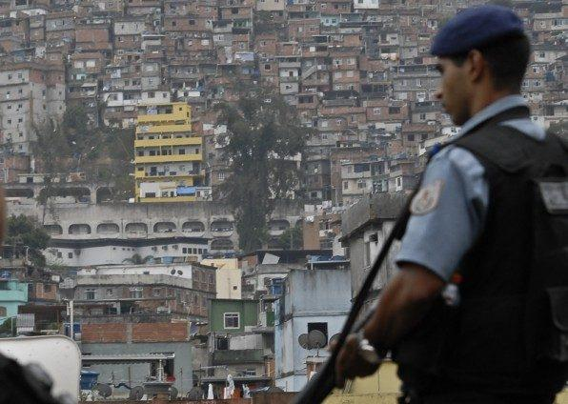

**Figure 2**: Santa Cruz, Rio de Janeiro, Brazil. Source: https://www.estadao.com.br/politica/blog-do-fausto-macedo/pf-prende-na-favela-do-rola-mais-um-pelo-assassinato-de-agente-federal-no-rio/.

Originated in Rio de Janeiro, we aim to invest in enhancing the beauty of black women through our products. Educating and directing is the DNA of our brand. This way we encourage all curly and kinky women to have good hair habits so that, in return, their strands are shaped and silky. (PRETA PORTER, 2023, n. p.).



**Figure 3**: Preta Porter complete kit: shampoo, conditioner, curl activator, mix of African oils and shine spray, R$ 119.90 (US$ 24) and hair comb, R$ 12.90 (US$ 2, 6). Source: https://lojapretaporter.com.br/loja/kit-completo-preta-porter/.

Baptista’s design leadership in developing the product labels and packaging was a key step in giving Black women living in favelas a step towards becoming more visibly represented in cosmetics products. Her other work continues to champion Diversity, Equity and Inclusion and she is part of the group ‘Cariocas Startups Black’ (Cariocas are people born in Rio de Janeiro). The Cariocas Startups community has the mission of fostering the ecosystem of entrepreneurship, technology and innovation in the city of Rio de Janeiro through representation and information.

**3.3 naPorta**

The second case study in this paper focuses on naPorta, a startup whose founder and CEO is a resident of a slum in São Paulo’s east zone, Sanderson Pajeú. At the age of 30, he entered a startup competition at South Summit Brazil 2022, an innovation and technology event that took place in Porto Alegre. One of ten finalists in the competition, naPorta is a logistics and delivery company that creates jobs for favela residents. All employees are residents of the communities, from the operational leaders of the support centres to the delivery drivers. The company's strategy is to use regularised infrastructure such as distribution centres, which are located close to the entrances of favelas. naPorta partner companies deliver products to these distribution centres, and the system notifies naPorta couriers, who deliver to end consumers within the communities.

Recently in 2023, the company launched a communications agency that promotes the platform's brands to consumers within the favelas. This gives residents access to products from retail giants such as C&A and Shopee, as well as important Brazilian retailers such as Riachuelo and Mercado Livre. On its website, the company describes its mission as follows: “To deliver convenience and digitalisation to everyone, regardless of region and access. Helping with the professionalisation and employability of the areas we operate in and developing a strong brand connected with our purpose” (ABRALOG, 2024).

The naPorta case study is a relevant example of slum-driven design because it demonstrates novel ways for companies outside favelas to enter and navigate these communities. It also gives consumers in favelas, who are often at the base of the pyramid, an opportunity to participate in and benefit from the wide choice of products and services available through market mechanisms: setting the stage for rapid social and economic transformation. The distinct visual design of the naPorta’s vehicles as they operate within the favelas, provides a visible and tangible link between favela residents and the broader market. This is significant because “when the poor are treated as consumers, they gain benefits such as respect, choice and self-esteem, and have an opportunity to escape the poverty trap." (PRAHALAD, 2005, p. 101-102).

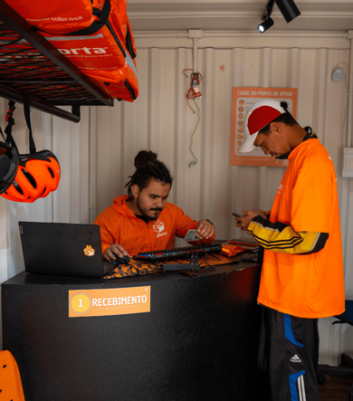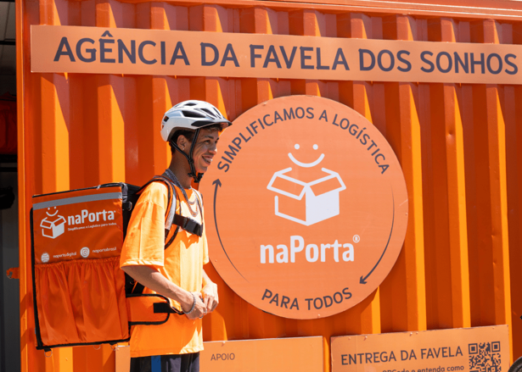

**Figure 4**: Images of naPorta containers in the Rio das Pedras favela, in Rio de Janeiro. Source: https://naporta.digital/quem-somos/.



**Figure 5**: NaPorta startup user journey. Source: <https://naporta.digital/quem-somos/>.

**3.4 Favela Brasil Xpress**

Our third case study, which is also in the field of Logtech (logistics technology), is Favela Brasil Xpress (FBX), which has been in operation since 2020 in Paraisópolis, located in the south of São Paulo, and one of the five largest favelas in Brazil. When pandemic restrictions in Brazil led to soaring e-commerce sales, 20-year-old Givanildo Pereira noticed a problem that impacted the lives of many residents of Paraisópolis, where he still lives today: the difficulty of receiving products purchased online. The community is marginalised by companies that do not serve the region due to fear, prejudice, or difficulty in access.

Pereira’s solution was to come up with a simple process: a favela resident makes a purchase at partner e-commerce sites, indicates their zip code, and adds a reference point for their home. Distribution centres send packages to a strategic point in each community—usually a place with easy and safe access for trucks to enter and exit. Similar to naPorta, the startup's team is made up 100% of favela residents. Transport varies according to the demands of each community’s often rugged topographical characteristics. Deliveries are made by motorcycle, bicycle, tuk-tuks (a version of vehicles commonly seen in India and Southeast Asia), on foot, or with electric vehicles. Young people who are unable to obtain a license or have their own vehicle are offered alternatives for them to be able to work. The startup conducts around 30% of its operations with bikes or electric vehicles.

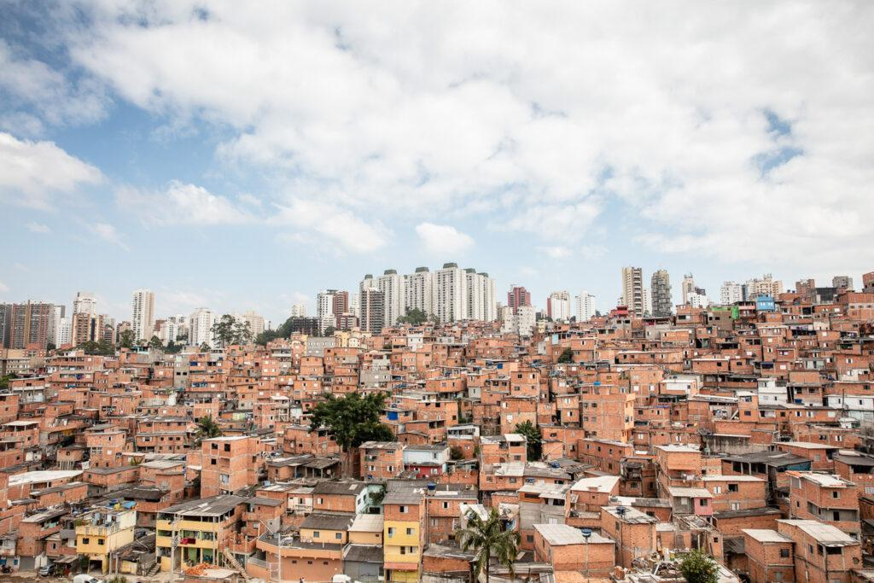

**Figure 6**: Paraisópolis: Favela located south of the city of São Paulo, one of the 5 largest in the country. Photo by Gui Christ - National Geographic. Source: https://wikifavelas.com.br/index.php/Parais%C3%B3polis

FBX operates in seven favelas in São Paulo and two in Rio de Janeiro. In each favela, it makes around 2,500 deliveries in a single day. In its two years of operation, FBX delivered more than one million packages valued at US$100,000 in goods, and helped 800,000 customers receive goods at home. FBX received two awards, winning first place in the BBM Logistics Award (Startups Category) and first place in the Brazil/United Kingdom Urban Logistics Challenge. The group has an ambitious expansion plan for all regions of the country, including São Luís do Maranhão, Recife and Brasília. Its goal is to open 50 new bases and deliver 10 million packages in 2024. For this expansion, the company raised US$180,000 through the DIVI hub crowdfunding platform. The fundraising was the first conducted by the Bolsa das Favelas (Favela's Funding) project, a partnership between DIVI hub and G10 das Favelas, a group of leaders and social impact entrepreneurs from favelas who join forces in favour of economic development and community protagonism.

FBX’s unique contribution is based on its innovative use of Logtech. In partnership with Google and the Brazilian retailer Americanas, the startup created an unofficial postal code system, called a digital address, to circumvent the absence of an official postal code in favela residences, and mitigate the challenges of these communities outside of legal, state-supported infrastructure. Using visual identification of residences, wayfinding, and wall signs, the system was able to use slum-driven design to map the exact locations for deliveries, even in difficult-to-access locations.

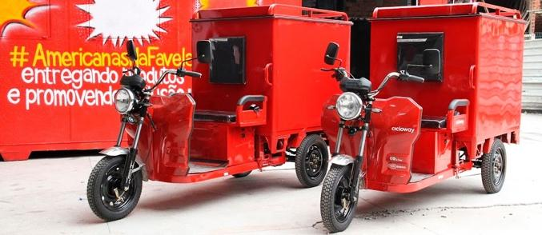

**Figure 7**: Paraisópolis: Digital address fixed on the external wall of a house in the favela and Tuk tuk delivery. Source: https://favelabrasilxpress.com/

**4. Conclusion: Slum-driven design is awe-driven design**

It is common sense that difficulties bring opportunities. The Chinese ideogram for the word crisis mixes the notions of risk (WEI) and opportunity (JI). Dacher Kelner (2023) treats the issue of awe as a driving force for solutions. In this sense, it places visual design as a fundamental element for drafting alternatives in the face of unwanted situations. In the favela context, awe is the incentive to mitigate problems.

As you look at the source of visual awe, neurochemical signals move from your retinas to the visual cortex in the back of the brain, which begins to construct the rudiments of images out of angles of lines, patterns of light and dark, early signs of shape, texture, and colour. […] These neurochemical signals will next activate regions of the brain that store your ideas. (KELNER, 2023, p. 171).

The most effective initiatives in the favela context are those that use technology for real effects, which affect and improve people's lives when they live in vulnerable circumstances. These are proposals designed in the context of the smartphone, considering the use of the smartphone, but applied outside the smartphone universe. The user experience occurs thanks to technology, but to facilitate tangible issues, such as the delivery of goods to regions that do not officially exist on city maps. "In times of full attention being paid to smartphone screens, looking out of the bus windows is getting rarer and rarer. Today's window is a different one, on another level, one that's mostly virtual” (CURCIO, 2020, n. p.).

The private sector’s strategy in mitigating issues that the state cannot legally resolve makes it possible for large groups, including foreigners, to expand their consumer market by taking advantage of the favelas' significant GDP through these devices. Piercing the virtual bubble to make these solutions possible in the favela context is perhaps the key to successful initiatives in this field. And design plays an essential role in building these multi-platform bridges and materializing paths to didactic, friendly and easy-to-understand interfaces based on their most basic principles of syntax and visual composition. Slum-driven design is therefore a dormant opportunity for companies to expand in a world that has tended to remain stagnant for many years, but which is now experiencing stirrings of design-driven change.

**Referências**

BARCELLOS, Carlos; ZALUAR, Anna. Homicídios e disputas territoriais nas favelas do Rio de Janeiro. **Revista de Saúde Pública**, São Paulo, v. 48, n. 1, p. 94-102, 2014. Disponível em: <https://www.scielo.br/j/rsp/a/GJhFgfn/?lang=pt>. Acesso em: 28 dez. 2024.

BARRENCE, André. **Brands boosted by Google's Black Founders Fund**. Blog do Google Brasil, 2023. Disponível em: <https://blog.google/intl/pt-br/produtos/black-founders-fund-fechando-o-ano-com-novas-startups-investidas-e-o-compromisso-renovado-para-2024/>. Acesso em: 28 dez. 2024.

C&A LANÇA MODALIDADE de entrega nas favelas e regiões periféricas de São Paulo. **Abralog**, 2024. Disponível em: <https://www.abralog.com.br/noticias/ca-lanca-modalidade-de-entrega-nas-favelas-e-regioesperifericas-de-sao-paulo>. Acesso em: 28 dez. 2024.

CANDA COMEÇA A ENTREGAR nas favelas os produtos vendidos no seu e-commerce. O Globo, 2022. Disponível em: <https://oglobo.globo.com/blogs/capital/post/2022/09/canda-comeca-a-entregar-nas-favelas-osprodutos-vendidos-no-seu-e-commerce.ghtml>. Acesso em: 28 dez. 2024.

CURCIO, Gustavo O. F. **Casas do Brasil**: conexões paulistanas. São Paulo: Museu da Casa Brasileira, 2020.

CURCIO, Gustavo O. F.; SHIMOMURA, André P. Remote design for a better life: popular housing on the outskirts of São Paulo and Rio de Janeiro. **Liveable Environments & Architecture International Congress**, Trabzon, Turquia, 2021.

EDIÇÃO NACIONAL da Expo Favela Innovation é aberta em São Paulo. **Agência Brasil**, 2023. Disponível em: <https://agenciabrasil.ebc.com.br/geral/noticia/2023-12/edicao-nacional-da-expo-favelainnovation-e-aberta-em-sao-paulo>. Acesso em: 28 dez. 2024.

EXPO FAVELA. 2024. Disponível em: <https://expofavela.com.br/>. Acesso em: 28 dez. 2024.

FAVELA LOG: empresa de distribuição nas favelas chega ao mercado. **Observatório 3º Setor**, 2024. Disponível em: <https://observatorio3setor.org.br/noticias/sociedade/favela-llog-empresa-de-distribuicao-nasfavelas-chega-ao-mercado/>. Acesso em: 28 dez. 2024.

FAVELAS DOBRARAM na última década; PIB de R$ 200 bilhões. **Rede Brasil Atual**, 2024. Disponível em: <https://www.redebrasilatual.com.br/cidadania/favelas-dobraram-na-ultima-decada-pib-200-bilhoes/>. Acesso em: 28 dez. 2024.

FAVELA BRASIL XPRESS: Logtech de impacto social faz entregas em comunidades. **Startups**, 2024. Disponível em: <https://startups.com.br/noticias/favela-brasil-xpress-logtech-de-impacto-social-faz-entregasem-comunidades/>. Acesso em: 28 dez. 2024.

KELNER, Dacher. **Awe**: the transformative power of everyday wonder. Londres: Penguin Random House UK, 2023.

LUMUMBA, Jane. Impossible possibilities: The fragility and resilience of Lagos. In: GIDWANI, Bhagwan S.; PANDIT, Shyam M. (Eds.). **Building resilience in cities under stress**. New York: Springer, 2016. p. 38-49.

MACEDO, Fausto. **PF prende na favela do Rola mais um pelo assassinato de agente federal no Rio**. Estadão, 2020. Disponível em: <https://www.estadao.com.br/politica/blog-do-fausto-macedo/pf-prende-na-favela-do-rola-mais-um-pelo-assassinato-de-agente-federal-no-rio/>. Acesso em: 28 dez. 2024.

MARX, Colin. Introduction: the puzzles of informal economy. In: LEDENEEVA, Alena (org.). **Global Encyclopaedia of Informality.** Volume 2: Understanding Social and Cultural Complexity. London: University College London, 2018, p. 7-10.

MEIRELLES, Renato; ATHAYDE, Celso. **Um país chamado favela**: a maior pesquisa já feita sobre a favela brasileira. São Paulo: Gente, 2014.

MEIRELLES, Renato. **Brazilian Favelas Hold US$27.7 Billion in Purchasing Power**. Rio On Watch, 2020. Disponível em: <https://rioonwatch.org/?p=57787>. Acesso em: 28 dez. 2024.

MEIRELLES, Renato. **Quase 40% dos moradores das favelas no Rio têm negócio próprio**. Agência Brasil, 2023. Disponível em: <https://agenciabrasil.ebc.com.br/direitos-humanos/noticia/2023-07/quase-40-dos-moradoresdas-favelas-no-rio-tem-negocio-proprio>. Acesso em: 28 dez. 2024.

MULHERES PRETAS e Geração Z lideram empreendedorismo nas favelas. **Meio & Mensagem**, 2024. Disponível em: <https://www.meioemensagem.com.br/womentowatch/mulheres-pretas-e-geracao-z-lideramempreendedorismo-nas-favelas>. Acesso em: 28 dez. 2024.

**NYENRODE BUSINESS UNIVERSITET**. Jai Ho Dharavi. 2009. Disponível em: <https://www.nyenrode.nl/businesstopics/europeindia/Pages/%E2%80%9CJaiHo%E2%80%9DDharavi.aspx>. (Página indisponível). Acesso em 28 dez. 2024.

O COMPLICADO ACESSO aos alimentos frescos nas favelas. **Insper**, 2024. Disponível em: <https://www.insper.edu.br/noticias/o-complicado-acesso-aos-alimentos-frescos-nas-favelas/>. Acesso em: 28 dez. 2024.

OTTAVIANI, Jacob; ADESHOKAN, Oluwatosin. **How Makoko, Nigeria’s floating slum went digital with new mapping project**. CNN News Article, 2020. Disponível em: <https://edition.cnn.com/2020/02/26/africa/nigeria-makoko-mapping-intl/index.html>. Acesso em: 28 dez. 2024.

PÁGINA INICIAL. **Favela Brasil Xpress**, s. d. Disponível em: <https://favelabrasilxpress.com/>. Acesso em: 28 dez. 2024.

PÁGINA INICIAL. **Novo Outdoor Social**, 2023. Disponível em: <https://nosinteligencia.com.br/>. Acesso em 28 dez. 2024.

PÁGINA INICIAL. **Preta Porter**, 2023. Disponível em: <https://www.lojapretaporter.com.br/>. Acesso em 28 dez. 2024.

PARAISÓPOLIS. **WikiFavelas**, s. d. Disponível em: <https://wikifavelas.com.br/index.php/Parais%C3%B3polis>. Acesso em: 28 dez. 2024.

PRAHALAD, Coimbatore K. **A riqueza na base da pirâmide**: como erradicar a pobreza com o lucro. Porto Alegre: Bookman, 2005.

PRETA PORTER COMPLETE KIT: shampoo, conditioner, curl activator, mix of African oils and shine spray, R$ 119.90 (US$ 24) and hair comb, R$ 12.90 (US$ 2, 6). **Preta Porter**, s. d. Disponível em: <https://lojapretaporter.com.br/loja/kit-completo-preta-porter/>. Acesso em: 28 dez. 2024.

QUEM SOMOS. **NaPorta**, s. d. Disponível em: <ttps://naporta.digital/quem-somos/>. Acesso em: 28 dez. 2024.

SARINGER, Giuliana. **Entrega em favelas cresce e conquista novos públicos**. UOL Economia, 2022. Disponível em: <https://economia.uol.com.br/noticias/redacao/2022/05/07/entrega-em-favelas.html>. Acesso em: 28 dez. 2024.

SLUMS CONTRIBUTE over 7.5% to GDP: Study. **The Economic Times**, 2013. Disponível em: < https://economictimes.indiatimes.com/news/economy/indicators/slums-contribute-over-7-5-togdp-study/articleshow/24217724.cms>. Acesso em: 28 dez. 2024.

THE FORTUNE at the Bottom of the Pyramid: Eradicating Poverty through Profits. **Wharton School**, 2005. Disponível em: <https://knowledge.wharton.upenn.edu/article/the-fortune-at-the-bottom-of-the-pyramideradicating-poverty-through-profits/>. Acesso em: 28 dez. 2024.

THÉRY, Hervé; SAGLIO-YATZIMIRSKY, Marie-Caroline; LANDY, Frédéric. **Megacity Slums: Social Exclusion, Space and Urban Policies in Brazil and India**. Marie-Caroline Saglio-Yatzimirsky, and Frédéric Landy (eds.). Londres: Imperial College Press, 2014.

WILLIS, Kevin. The Entrepreneurial Slum: Civil Society, Mobility and the Co-production of Urban Development. **Urban Studies**, v. 49, n. 4, 2009, p. 729-746.

WYLANT, Barry. Design Thinking and the Experience of Innovation. **Design Issues**, v. 24, p. 3-14, 2008. Disponível em: <https://direct.mit.edu/desi/article-abstract/24/2/3/60197/Design-Thinking-and-the-Experience-of-Innovation?redirectedFrom=fulltext>. Acesso em 28 dez. 2024.

**Design orientado a favelas: inclusão e incursão em torno do empreendedorismo essencial nas favelas urbanas brasileiras**

**Resumo**

Entender a complexidade e o potencial das favelas ao redor do mundo tem sido um desafio para empreendedores. Muitos perceberam o potencial de geração de riqueza em comunidades periféricas em cidades como São Paulo ou Mumbai. Startups baseadas em estratégias de comunicação baseadas em design floresceram rapidamente. Tais estratégias são decisivas para o sucesso desses modelos de negócios inovadores, que superam as dificuldades e impasses de infraestrutura dessas regiões fora das cidades. Neste artigo, apresentamos exemplos desenvolvidos no Brasil, como parte de pesquisa colaborativa entre a FAUUSP e a Escola de Design da Universidade de Leeds.

**Keywords**

Design orientado a favelas; Favela; Startups.

**Como citar**

KHARA, Arjun; CURCIO, Gustavo O. F. Slum-Driven Design: Inclusion and Incursion Around Essential Entrepreneurship in Brazil’s Urban Favelas. [S. l.], v. 2, n. 4, 2024, p. 1-20.

Recebido em: 01/11/2024.

Aceito em: 30/11/2024.